Practical - 6

Task - 1:
Compilation and Execution:
Client.c:
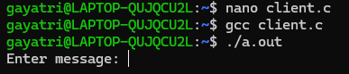

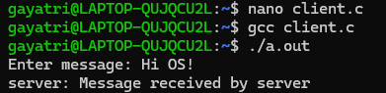

Server.c
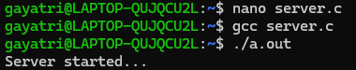

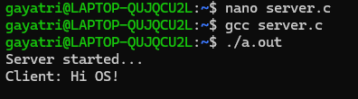

Task - 2:
